**Traffic Regulations and Infrastructure in Different Countries and Their Impact on Traffic Accidents**

**Introduction**

Traffic regulations and infrastructure are pivotal components of urban and rural mobility, significantly impacting traffic safety and efficiency. As globalization has increased mobility and the number of vehicles, the risk of traffic accidents has risen. Effective traffic regulations and high-quality infrastructure are essential to mitigate these risks and enhance the safety and quality of life for citizens. This essay examines the relationships between infrastructure quality, traffic rule enforcement, and traffic safety across selected countries: Brazil, British Virgin Islands, China, Colombia, India, Latin America & Caribbean, Mexico, South Asia, and Turkey.

**Traffic Regulations and Infrastructure**

Different countries have implemented various traffic regulations and infrastructure improvements to address the challenges posed by increased vehicular traffic. For instance, China has invested heavily in road infrastructure, developing extensive highway networks and implementing strict traffic regulations. These efforts aim to reduce traffic congestion and improve safety. Similarly, Brazil has focused on modernizing its road networks and enforcing traffic rules more rigorously. In India, the government has launched several initiatives to upgrade road infrastructure and enhance traffic management systems.

The quality of infrastructure, such as well-maintained roads, clear markings, and proper lighting, plays a crucial role in ensuring traffic safety. In China, for example, the average investment in infrastructure has significantly increased, leading to better road conditions and reduced accident rates. The mean investment in China was approximately $9.33 billion, with a substantial growth rate of 43.93%. This investment has resulted in improved road conditions, which, coupled with strict traffic regulations, has contributed to a decrease in traffic accidents.

In contrast, countries like Mexico and regions like Latin America & Caribbean have faced challenges in maintaining consistent investment in infrastructure. Mexico, for example, showed a mean investment of $842.80 million but experienced a negative growth rate of -10.63%. This inconsistency in investment has impacted road conditions and contributed to higher accident rates. The average mortality rate in Mexico was found to be 7.80 per 100,000 population, reflecting the need for better infrastructure and stricter enforcement of traffic rules.

**Real-Time Analysis and Findings**

A detailed analysis was conducted using datasets from the selected countries to understand the impact of traffic regulations and infrastructure on traffic accidents. The analysis involved examining investment trends, mortality rates, and Social Progress Index (SPI) performance.

**Investment Trends**: The investment data revealed significant disparities among the countries. China exhibited the highest mean investment, followed by South Asia and Turkey. These investments have been instrumental in improving road conditions and reducing accident rates. On the other hand, countries like Mexico and the Latin America & Caribbean region showed negative growth rates in investment, indicating a need for increased and sustained funding for infrastructure development.

* **Brazil**: The mean investment was approximately $4.97 billion, with a median of $1.33 billion. The growth rate was approximately 9.17%.
* **British Virgin Islands**: No significant investments were recorded.
* **China**: Exhibited the highest mean investment at $9.33 billion and a growth rate of 43.93%.
* **Colombia**: Mean investment was around $2.03 billion, with a growth rate of 3.43%.
* **India**: Recorded a mean investment of $3.43 billion and a growth rate of 16.83%.
* **Latin America & Caribbean**: Mean investment was about $6.13 billion, but had a negative growth rate of -4.14%.
* **Mexico**: Showed a mean investment of $842.80 million with a negative growth rate of -10.63%.
* **South Asia**: Had a mean investment of $3.74 billion and a growth rate of 18.50%.
* **Turkey**: Mean investment was $5.42 billion with a growth rate of 9.15%.

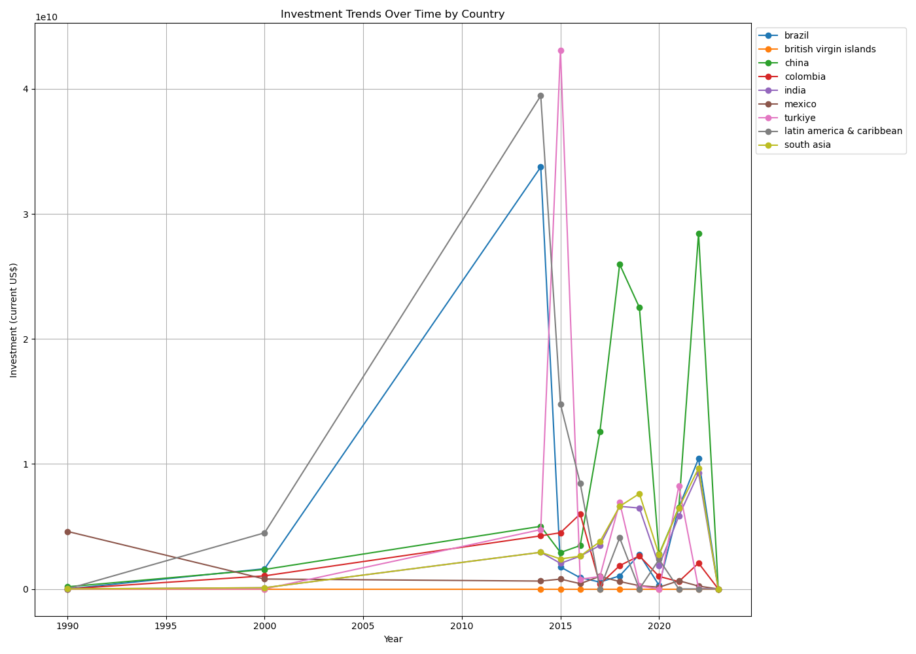

Figure 1.1 investment trends

**Mortality Rates**: Mortality rate data provided insights into the effectiveness of traffic regulations and infrastructure quality. Countries with higher investments and better infrastructure, such as China and Turkey, reported lower average mortality rates. In contrast, regions with lower investments and inconsistent infrastructure development, like Mexico and Latin America & Caribbean, showed higher mortality rates.

* **Brazil**: Average mortality rate was 11.32 per 100,000 population.
* **British Virgin Islands**: No mortality rates recorded.
* **China**: Average mortality rate was 10.78 per 100,000 population.
* **Colombia**: Average mortality rate was 10.20 per 100,000 population.
* **India**: Average mortality rate was 9.18 per 100,000 population.
* **Mexico**: Average mortality rate was 7.80 per 100,000 population.
* **Turkey**: Average mortality rate was 5.20 per 100,000 population.
* **Latin America & Caribbean**: Average mortality rate was 10.48 per 100,000 population.
* **South Asia**: Average mortality rate was 8.97 per 100,000 population.

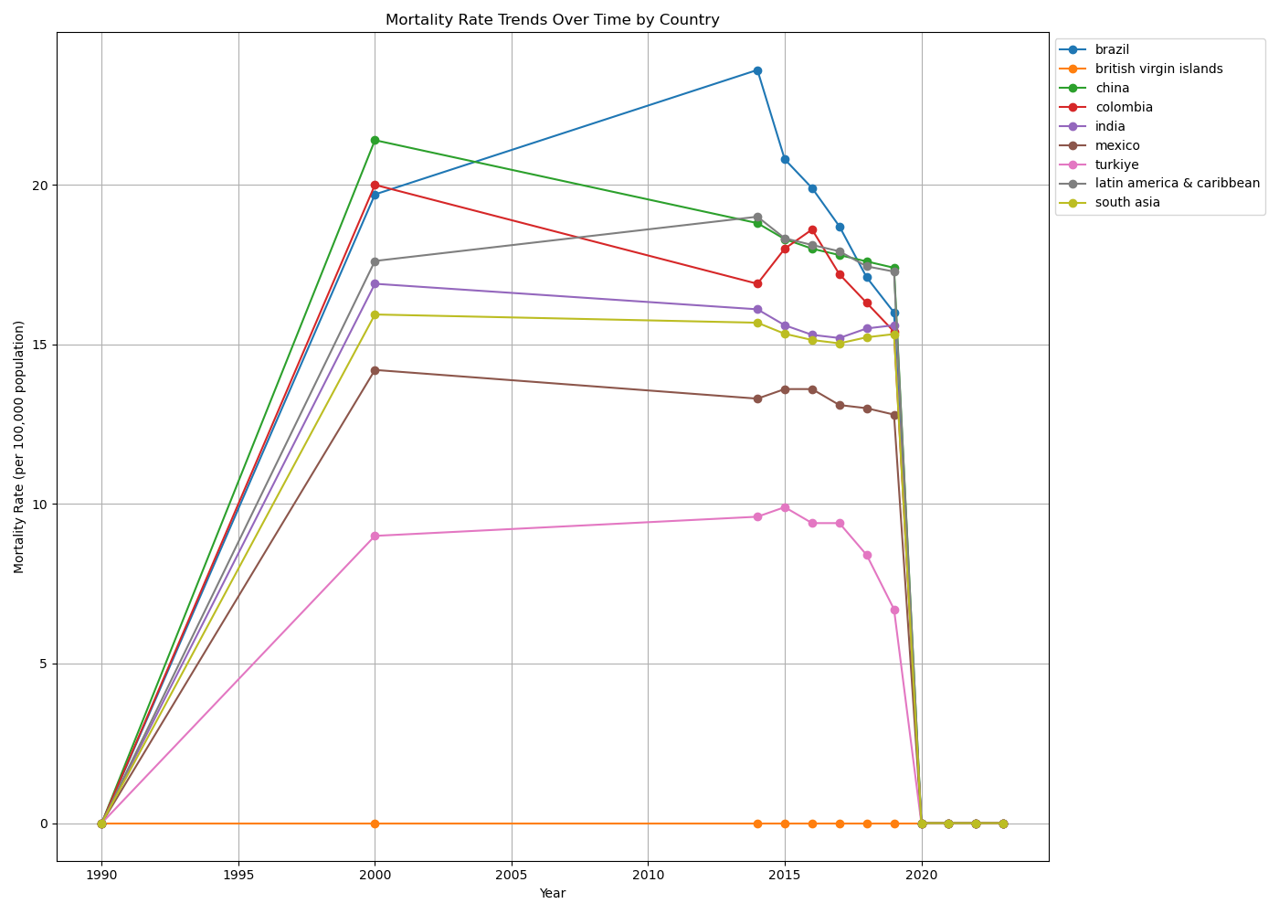

Figure **1.**2 mortality trends

**Social Progress Index (SPI)**: The SPI analysis highlighted the social and economic impacts of infrastructure and traffic regulations. Countries with higher SPI scores, indicating better social progress and development, generally showed lower accident rates. Specifically:

* **China**: Achieved the highest SPI scores, reflecting the significant social and economic progress in tandem with its extensive infrastructure investments.
* **Turkey**: Also demonstrated high SPI scores, correlating with its substantial investments and improvements in traffic safety.
* **India**: While facing numerous challenges, India's SPI scores indicate progress in social development, supported by its initiatives in road infrastructure and traffic management.
* **Brazil and Colombia**: These countries showed moderate SPI scores, reflecting ongoing efforts in infrastructure development and social progress.
* **Mexico and Latin America & Caribbean**: The lower SPI scores in these regions highlight the need for more consistent and effective investments in infrastructure and social development.



**Conclusion**

The analysis of traffic regulations and infrastructure in the selected countries reveals a clear link between investment in infrastructure, the enforcement of traffic rules, and traffic safety. Countries like China and Turkey, which have made significant investments in their road networks and implemented strict traffic regulations, have seen a reduction in traffic accidents and mortality rates. Conversely, countries with lower and inconsistent investments, like Mexico and regions like Latin America & Caribbean, continue to face higher accident rates.

This study underscores the importance of sustained investment in infrastructure and the enforcement of traffic regulations to improve traffic safety. Policymakers should consider these factors when developing strategies to reduce traffic accidents and enhance the quality of life for citizens. By adopting best practices from countries with successful outcomes, regions struggling with high accident rates can implement effective measures to improve their traffic systems.